6th International Gestalt Research Conference
5-7 September 2025, Birmingham-UK
Call for Papers

Building the evidence base for Gestalt Therapy

The International Gestalt Research Conference exists to bring together, and enthuse, researchers and practitioners in the application, sustainment and development of Gestalt Therapy as a professional, evidence-based practice.

We welcome submissions from students, practitioners and experienced researchers alike. We accept submissions for research papers and symposia, discussions, workshops and poster presentations.

Areas for submission may include current, past or future research projects, case studies or projects such as how you have gone about fund-raising, participant sourcing or ethics. A 300-word abstract is required for every submission type for consideration and assessment by the peer review panel.

Information and guidance about the different submission types can be found on our submission guidelines web page.

The deadline for submissions is 23:59 GMT on 15th February 2025.
For applications, please use the Applications Submissions Form.

Event Sponsors
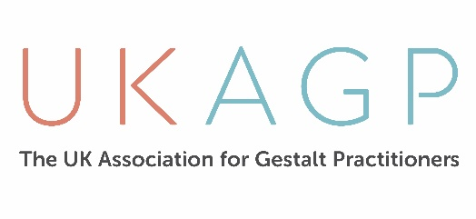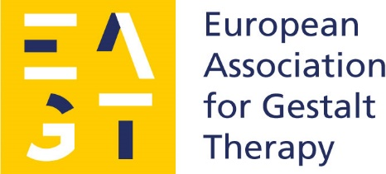
Guidelines
We welcome submissions from students, practitioners and experienced researchers alike. We accept submissions for research papers and symposia, discussions, workshops and poster presentations.

There are a number of different ways that you can present your work such as:
- Presentation of 30 minutes followed by 15 minutes discussion e.g. completed research projects
- Short presentation of 15 minutes followed by 10 minutes discussion e.g. partially completed Masters or PhD research projects or ideas in development
- Market place stand: opportunity to engage in dialogue about your research
- Poster presentation
- Experiential workshop for up to 90 minutes exploring measurements or methodologies

We want to provide a space for you to engage the community in your research. If there is another format you prefer, please let us know on your submission form.

A 300-word abstract is to be submitted to the peer review panel by 23:59 GMT on 15th February 2025.

Event Details
Dates: 5th-7th September 2025
Venue: Millennium Point, Curzon Street, Birmingham, B4 7AP, UK
Website: https://www.ukagp.org.uk/2025-international-research-conference

For further information
- Call for Papers and Program – contact Christine on conference@ukagp.org.uk
- General queries – contact Hannah on events@ukagp.org.uk

